**IBM ASSIGNMENT 1**

**CLOUD APPLICATION DEVELOPMENT**

1) list1=[]

list1.insert(0,1)

list1.insert(1,10)

list1.insert(2,'Nikhila')

print(list1)

list1.remove('Nikhila')

print(list1)

list1.append(2)

list1.append(8)

print(list1)

list1.sort()

print(list1)

list1.pop()

print(list1)

list1.reverse()

print(list1)

OUTPUT

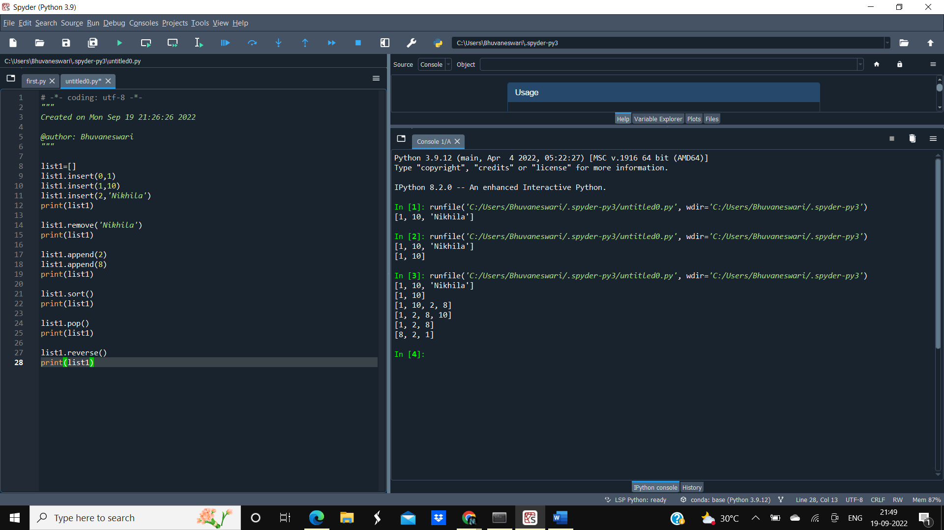

2)CALCULATOR

print("SIMPLE CALCULATOR")

while True:

print("Enter the operation you want to perform")

print("1.Addition")

print("2.Subtraction")

print("3.Multiplication")

print("4.Division")

print("5.Modulus")

ch=input("Enter your choice(1/2/3/4/5):")

if ch in('1','2','3','4','5'):

num1=float(input("Enter the first number:"))

num2=float(input("Enter the second number:"))

if ch=='1':

print("Addition result:"+num1+num2)

if ch=='2':

print("Subtraction Result:"+num1-num2)

if ch=='3':

print("Multiplication Result:"+num1*num2)

if ch=='4':

print("Division result:"+num1/num2)

if ch=='5':

print("Modulus result:"+num1%num2)

op=input("Do you want to continue(y/n)?")

if op=='n':

break

else:

print("Invalid input")

OUTPUT

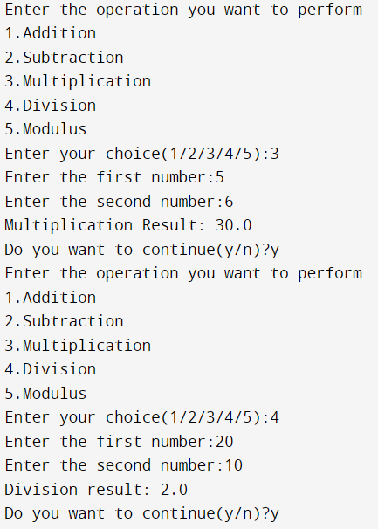 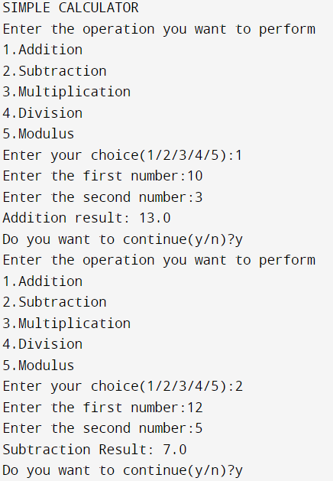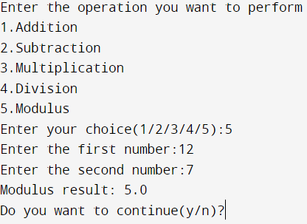

3)

# -*- coding: utf-8 -*-

#concatenation

str1="My name is"

str2=" Nikhileshwari"

print("Concatenation result:",str1+str2)

#reverse

str="Cloud Application Development"

print(len(str))

print(str)

print("Reverse of string:",str[::-1])

#slicing

print(str[0:5])

print(str[1:29:2])

print(str[-1:-30:-2])

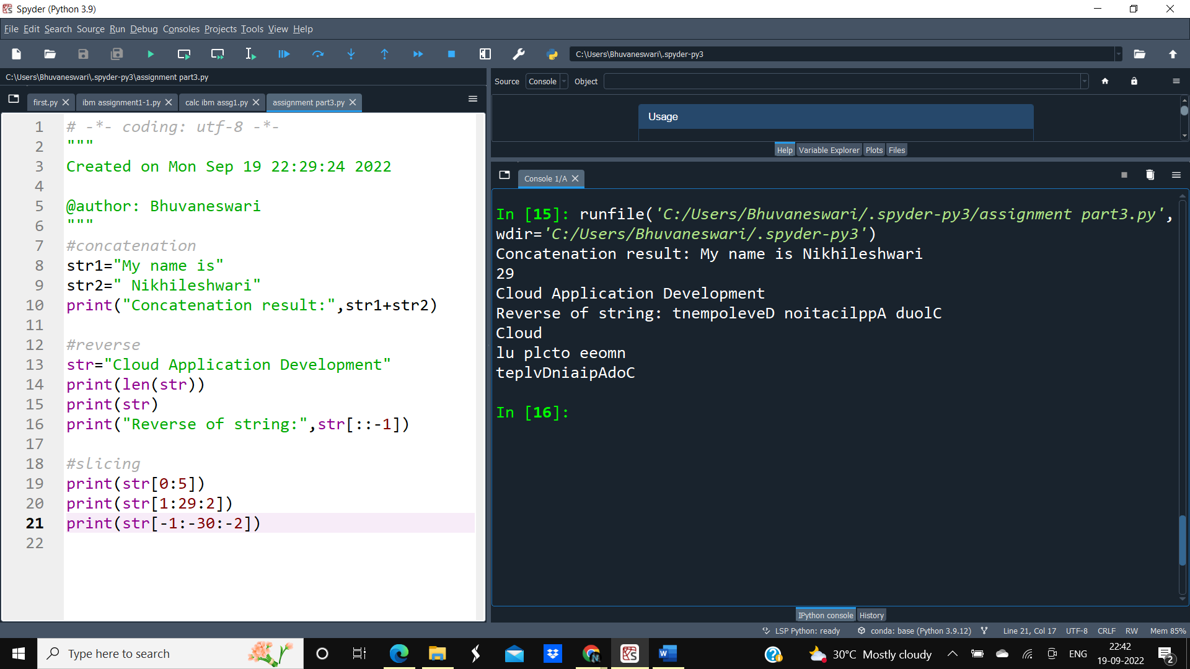

4)Python’s popularity can be attributed to the fact that it is

* easy to learn
* has a syntax that resembles natural language
* interpreted language
* provides a lot of libraries and frameworks
* active support is available

5)Django,web2py,Pyramid,Grok,CherryPy,Pylons project, FastAPI etc are a few other frameworks that can be used in python for web development.

6)WSGI stands for Web Server Gateway Interface. It is used in web application creation using python.